**What is organisational abuse?**

Organisational abuse (sometimes referred to as institutional abuse) is neglect and poor care practice within an institution or specific care setting such as a hospital or care home. This can range from a one-off incident to on-going ill-treatment.

**Background to organisational abuse: The Care Act 2014**

The Care and support statutory guidance identifies ten types of abuse, these are:

•Physical abuse

•Domestic violence or abuse

•Sexual abuse

•Psychological or emotional abuse

•Financial or material abuse

•Modern slavery

•Discriminatory abuse

•**Organisational or institutional abuse**

•Neglect or acts of omission

•Self-neglect

NHS logo

CSH Surrey Logo

**With acknowledgement to the Ann Craft Trust national safeguarding week resources 2020**

**Examples of organisational abuse:**

Organisational abuse doesn’t have to involve physical violence. It can be something as small as insisting that a person in care must drink their tea at the same time every day.

This is the sort of thing that many of us take for granted. But when the right to choose is taken away, it can count as abuse.

The abuse can either be a one-off incident or an ongoing culture of ill-treatment. The abuse can take many forms, including neglect, and poor professional practices as a result of the structure, policies, processes and practices in an organisation.

**1**

**2**

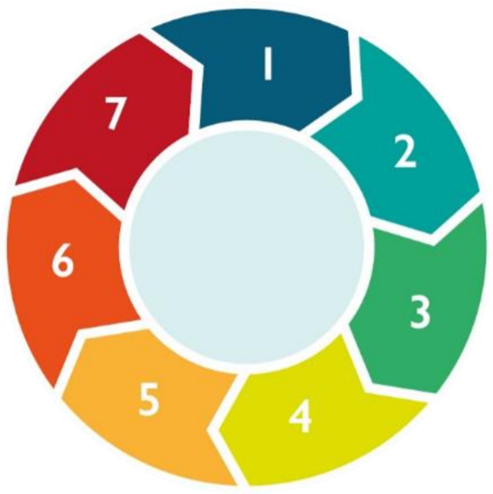

**Other resources:**

* [Surrey Safeguarding Adults Board Website](https://www.surreysab.org.uk/)
* [Ann Craft Trust – Organisational Abuse](https://www.anncrafttrust.org/institutional-abuse-definitions-signs-symptoms/)

**YouTube**:

* [Organisational Abuse](https://www.bing.com/videos/search?q=you+tube+organisational+abuse&docid=608052096742916873&mid=CDB8979E765F9BF452D1CDB8979E765F9BF452D1&view=detail&FORM=VIRE)

**3**

**7**

**4**

**Organisational Abuse**

**5**

**How to recognise signs of organisational abuse:**

•An unsafe, unhygienic or overcrowded environment.

•A strict or inflexible routine.

•Lack of privacy, dignity, and respect for people as individuals.

•Withdrawing people from community or family contacts.

•No choice offered with food, drink, dress or activities.

•No respect or provisions for religion, belief, or cultural backgrounds.

•Treating adults like children, including arbitrary decision-making.

Also be on the lookout for more telling signs of abuse, including cuts, bruises, and restraint. Another big warning sign is an organisation that discourages visits, or the involvement of friends and relatives.

**What to do if you are concerned about organisational abuse:**

Your safeguarding team are available to support with any safeguarding concerns including concerns surrounding organisational abuse.

Please call: Please add your safeguarding team.

You can also report your concerns directly to CQC.

**Why does organisational abuse happen?**

Like all types of abuse, there is no single cause of organisational abuse. It generally happens in institutions/organisations where staff are:

•Poorly trained.

Poorly supervised.

•Unsupported by management, or otherwise unaccountable.

•Bad at communicating.

Organisational abuse can involve more than one abuser. Though a culture that doesn’t recognise or respond to the actions of a lone abuser can be just as harmful to the adult at risk.

**4**

**6**