Domestic Abuse Awareness Week – comms toolkit
Comms toolkit contents:
- Background
- Editorial
- Social media messaging and assets targeting a range of audiences

Background
This year’s Domestic Abuse Awareness Week is 14 – 20 June. The county-wide approach is to raise awareness of domestic abuse and the various forms it comes in, with a focus on coercive control. Messaging is targeted at those who are in unhealthy/toxic relationships whether that be those being abused or the abuser. Young people are also being encouraged to spot the signs of unhealthy relationships
Editorial
Controlling behaviour in relationships
Abuse isn’t always physical
Domestic abuse and toxic relationships don’t always involve physical violence. It can be sexual, financial and emotional abuse and can happen to anyone. Sustained controlling behaviour such as regularly intimidating, bullying, criticising or threatening someone in a personal relationship, are all forms of what is called ‘coercive control’. This is a form of domestic abuse and is a criminal offence.
What is coercive control?
Typically one person in a personal relationship, whether it be a partner, spouse or family member, will control the other over a period of time and in ways that go largely unnoticed by friends and family. As well as the bullying and criticism, common traits of coercive control can include checking the other’s phone, making them dress in or look a certain way, wanting to know where they are and who they are seeing, restricting their money or cutting them off from friends and family.
Who can it happen to and what support is available?
Abuse can happen to anyone. Children and young people that are new to relationships might not know what a healthy relationship is. So it’s really important to help young people spot the signs when a relationship is unhealthy.
What support is available?
The LoveRespect website includes lots of helpful information for young people including a quiz to learn more about how healthy their relationship is, and advice on how to help a friend who might be spending time with someone who doesn’t treat them well. Drawtheline.uk is an online interactive platform for use on a smartphone to help young people to identify harmful, toxic and abusive behaviour in their relationships and also provides information, help and advice.
A range of help and support is available, including general advice and confidential listening. So if you think you may be in a controlling relationship or know someone who is, we are here to help when you are ready. Visit the Surrey Against Domestic Abuse website, call Surrey’s Domestic Abuse helpline provided by Your Sanctuary on 01483 776822 or use the Your Sanctuary confidential online chat to get advice, signposting and information just as you would over the phone. In an emergency you should always call 999.
Social media
General messaging
Asset | Messaging | Link
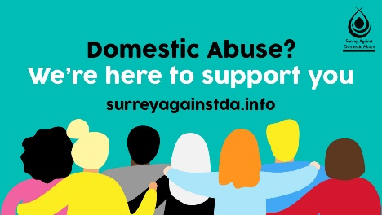 | Domestic abuse is more widespread than you think. It affects people of all ages, ethnicities, abilities and income levels. Home should be a safe place for all. Find out how you can help someone who is experiencing abuse #SurreyAgainstDA | https://www.healthysurrey.org.uk/domestic-abuse/how-to-help
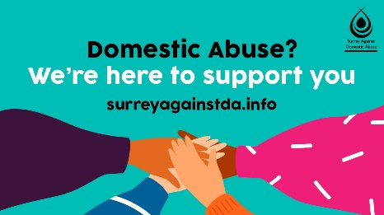 | If you are experiencing domestic abuse and can’t safely make a phone call, Your Sanctuary can offer support through a confidential online chat service that also has a live translation option #SurreyAgainstDA | https://chat.yoursanctuary.org.uk/
 | In danger, need the police, but can’t speak? Silent solution is a system that allows you to access help from the police in an emergency situation even if it’s not safe, or you are unable to speak #SurreyAgainstDA | https://www.healthysurrey.org.uk/domestic-abuse/help/silent-solutions
 | Galop are an organisation providing support for LGBTQ+ people experiencing domestic abuse. No more walking on egg shells, please don't suffer in silence #SurreyAgainstDA | https://www.healthysurrey.org.uk/domestic-abuse/help/support-for-lgbt-people
 | If someone is controlling or frightening you then it may be difficult for you to find out about your options or where to find help. By using a library computer, you can access all the information you need. It’s free and safe #SurreyAgainstDA | https://www.healthysurrey.org.uk/domestic-abuse/help/libraries

Coercive control messaging
Asset | Messaging | Link
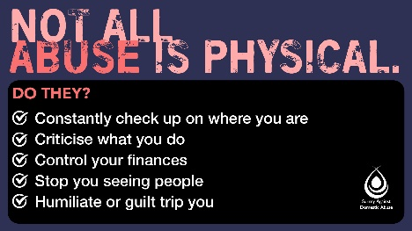 | Facebook:  ‘It takes away your life’.  This short film shows the devastating consequences of coercive and controlling behaviour.  We can't emphasise enough that domestic abuse isn't always physical. Having every aspect of your life controlled by someone can be just as hard, if not harder, to recover from and break free of.  For help call Surrey's Domestic Abuse helpline, provided by Your Sanctuary on 01483 776822 or chat online https://chat.yoursanctuary.org.uk/. In an emergency always dial 999.  Twitter:  ‘It takes away your life’.  This short film shows the devastating consequences of coercive and controlling behaviour.  Domestic abuse isn't always physical.  For help call Surrey's Domestic Abuse helpline, provided by Your Sanctuary: 01483 776822. In an emergency always dial 999 #SurreyAgainstDA | https://youtu.be/H9RXVZ6a0dI  https://youtu.be/H9RXVZ6a0dI
 | Facebook:  It can be really hard to recognise that you're being controlled and emotionally abused by someone close to you.  Many people living with a partner that are controlling, don’t always recognise it as.  Help is available. Call the domestic abuse helpline 01483 776822 or chat online https://chat.yoursanctuary.org.uk/. Always call 999 in an emergency. | https://www.healthysurrey.org.uk/domestic-abuse
 | Twitter:  Domestic abuse isn't always violent. It takes many forms including emotional and financial abuse and threats, intimidation and humiliation.  You do not have to live with being controlled. Your Sanctuary's helpline on 01483 776822 offers support #SurreyAgainstDA | https://www.healthysurrey.org.uk/domestic-abuse
Perpertrator messaging
Asset | Messaging | Link
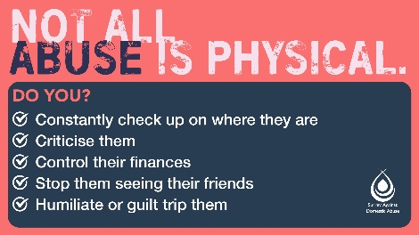 | Domestic abuse isn’t always physical. Controlling behaviour and emotional pressure are also abuse. Intimidating, bullying, criticising or threatening a partner or family member are all forms of coercive control #SurreyAgainstDA | https://www.healthysurrey.org.uk/domestic-abuse/what-is-it
 | “I’m stressed out.”  "They made me angry."  "I've never hit them.”  Domestic abusers will often try and excuse their behaviour. These excuses may be accepted by their family, friends and partners who want to believe them, but unless they face the root cause of their behaviour, they’re likely to offend again.  And again.  And again.  It’s a vicious cycle. In fact, around a third of reports to police involve repeat offenders.  RespectUK is a confidential helpline, email and webchat service for domestic abusers looking for help to stop their behaviour. | https://www.respect.uk.net/
 | Domestic abuse isn’t just physical violence. It’s sexual, financial and emotional abuse too.  If your behaviour is having an impact on your loved ones, contact RespectUK. It’s a confidential helpline for domestic abusers wanting help to stop their behaviour. | https://www.respect.uk.net/
Young people messaging (13-18yrs)
Asset | Messaging | Link
 | In a relationship?  Is it a ‘healthy’ one?  Take part in this quiz and learn more about how healthy your relationship is | https://loverespect.co.uk/questions/
 | Gets jealous when you spend time with your friends?  Accuses you of flirting when you’re just been friendly?  Forces you to do sexual things that you don’t want to?  Does this sound like abuse to you? Visit https://loverespect.co.uk/advice/is-it-abuse-im-not-so-sure/ for more information on the signs of a toxic relationship. | https://loverespect.co.uk/advice/is-it-abuse-im-not-so-sure/

 | What’s your healthy relationship IQ? Take the test here: | https://www.disrespectnobody.co.uk/quiz/
 | Toxic relationships can happen to anyone of any age. Learn more about the warning signs of a controlling relationship, and if you’re worried about your girlfriend’s or boyfriend’s behaviour, (or even your own), get help. | https://www.disrespectnobody.co.uk/relationship-abuse/signs-to-spot/

