SSAB National Safeguarding Week 2021 Comms

Monday - Emotional Abuse and Safeguarding Mental Health
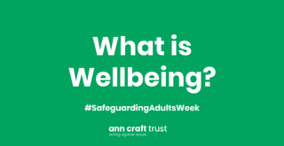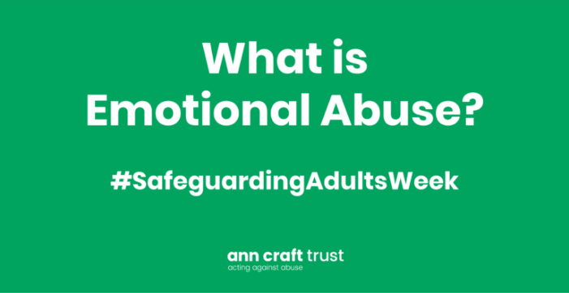
Mental Health Emotional abuse can have a devastating impact on mental as well as physical health. To have safer cultures, we need to prioritise wellbeing, and create a culture where people can speak out, be listened to and respected. Today at an individual level we are focusing on the importance of wellbeing and self-care. At an organisational level, today can be used to explore how organisations can be emotionally aware and promote respectful cultures where people can speak out without fear of reprimand.
What is Emotional Abuse? Read more.
Safeguarding in Sport: A Toolkit for Supporting Participants with their Mental Health. Download here.
Untold Stories – Domestic Abuse, Coercive Control and Emotional Abuse. Learn more.
How to Safeguard your wellbeing during the pandemic. Read more.
At times, work can be stressful and challenging. Read our guide about managing your mental health in the workplace.
Research into non-physical domestic abuse finds that 91% of survivors experienced psychological abuse at some point in their relationship. Read the full report from SafeLives.

Tuesday – The Power of Language
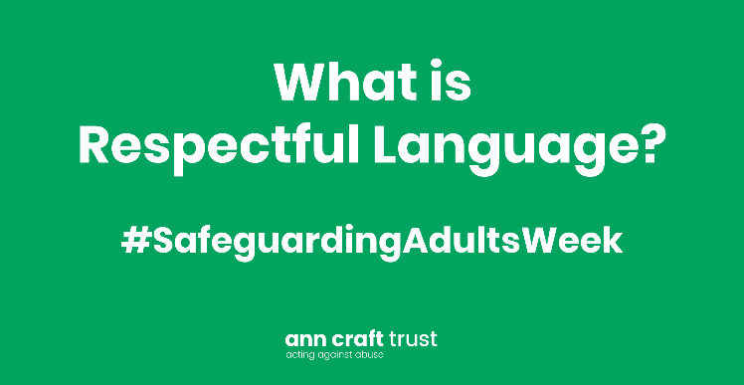
Language is vital in creating a positive culture and fostering inclusivity. Complex terminology and jargon can isolate individuals and result in people feeling excluded. In contrast, using respectful language can widen participation in services, organisations, and communities. Today, we want to encourage individuals and organisations to consider the language they use in their practice and how this relates to the people they work with. Is the language used in your setting actively inclusive?
The Power of Language in Safeguarding Practice- Read the Ann Craft Trust blog.
Explore the terminology resource from Sporting Equals. Download here.
Read the guidance from Victim Support and The Children’s Society about appropriate language when working with young people subject to sexual exploitation. Download here.
Language Creates Reality: How Becca’s community project is revolutionising language use in health and social care. Learn more.
End the Awkward- It can be difficult to know how to talk about disability. Explore these free resources that offer support and advice to help end the awkward! Discover more.

SSAB Policy & Procedures s7 -The use of language in safeguarding adults work
The ways we talk about abuse and neglect have an impact on how effective our response to safeguarding concerns will be.
• The way we use language can shape the way we think about things. Some ways of expressing things will help us think about matters in more useful ways than others.
• The language we use may have connotations for others that we don’t intend, and which creates barriers.
• Inconsistent use of language across organisations can lead to confusion, misunderstanding and can be the cause of failings in safeguarding work.

Here are some examples of how the language we use about safeguarding adults matters can be unhelpful, and what can be done differently.

7.1 Using “safeguarding” as a stand-alone noun

7.1.1 Examples
• “We have had four safeguardings this week”
• “This is not a safeguarding”

7.1.2 What effect this has
Using the word “safeguarding” in this way can lead to miscommunication. It can be used to refer to
• A safeguarding concern, about which a decision is needed as to whether there will be a safeguarding enquiry
• A safeguarding enquiry
• An instance of abuse or neglect

Using the same words to describe different things will lead to miscommunication. One person will understand a phrase to mean one thing and someone else will understand it to mean another. It is possible, likely even, that they won’t realise they mean two different things, and there can be unintended consequences.
An example can illustrate this:
• A person has a worry about abuse and neglect: there is a safeguarding concern.
• On looking into the matter, it is established there hasn’t been any abuse or neglect.
• The person who looked into it says “This is not a safeguarding”, by which they meant there wasn’t evidence that a person has experienced or has been put at risk of abuse or neglect.
• The meaning the person who had the concern takes from this hears “This is not a safeguarding” is that they were mistaken to have raised the concern. They remember this the next time a concern arises, which causes them to fail to take the action they should.

7.1.3 What to say instead
• “We have received four safeguarding concerns this week”
• “This safeguarding concern won’t lead to a safeguarding enquiry”

7.2 “Against”

7.2.1 Examples
• “We’ve had a safeguarding concern against us”
• “There have been five safeguarding referrals against this care home this year”

7.2.2 What effect this has
Talking this way sets up safeguarding enquiries as oppositional and confrontational, when what is needed is a collaborative approach. To say a safeguarding concern is “against” suggests the existence of the concern is problematic, whereas safe, vigilant systems should recognise and act on concerns.

7.2.3 What to say instead
• “There is a safeguarding concern about …”
• “There have been five safeguarding concerns regarding this care home this year”

7.3 Using quasi-judicial language

7.3.1 Examples
• “I carried out a disclosure interview” (when said by a Social Worker)
• “the evidence tells us”

7.3.2 What effect this has
It can be off-putting for the person at risk and their friends and family. It can get in the way of collaborative working.
Language like this can give the impression that the local authority has powers that it does not have, or the safeguarding adults enquiry has a status that is does not have. It can escalate the emotional temperature, which can have the perverse consequence of people doing less than they should as they fear the consequences of doing something wrong as they perceive the stakes to be high.

7.3.3 What to say instead
• “I spoke with the person”
• “The information gathered during the enquiry shows …”

7.4 Confusing findings with outcomes

7.4.1 Example
“The outcome of the enquiry is ‘substantiated’”

7.4.2 What effect this has
An enquiry may make a finding of whether or not there was abuse or neglect, or the risk of these. But this is not the same as the outcome. The key outcomes for a safeguarding enquiry are whether or not it has achieved what the person at risk wanted from the process.

7.4.3 What to say instead
“The information gathered during the enquiry shows that there had been abuse. The person at risk said at the beginning of the process that the outcomes they wanted were for the abuse to stop, and for them to be able to report the matter to the police. Both of these have happened.”

Wednesday- Digital Safeguarding
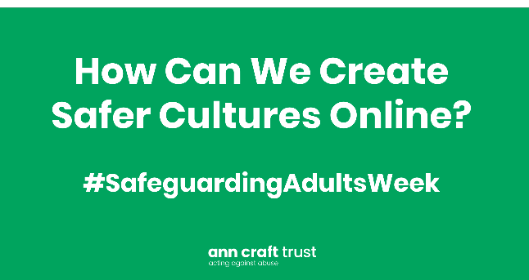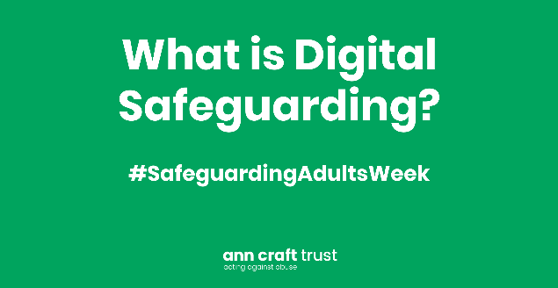
Over the past year an increasing proportion of our lives from work, education to sport and activity has moved online, This is likely to continue to some extent, even as lockdown restrictions ease. We want to use today to share best practice in relation to how to create safe cultures online.
Download the digital safeguarding resource pack.
Explore our introduction to digital safeguarding guide which explains what digital safeguarding is and provides tips and advice for staying safe online.
Do you know how to support young people who have been abused online? Learn more.
Safeguarding, Young People and Virtual Delivery: Creating Safer Online Spaces. Learn more.
How to Stay Safe Online – Guidance for Adults and Young People with Learning Disabilities. Read more.
Do you know how to spot the signs of digital scams? Learn more.
Listen to our latest podcast, Safeguarding in Esports with Fnatic.
What is cyber bullying? Read more.
Surrey Trading Standards - Report a fraud or a Scam

Surrey Trading Standards - Contact us
- Email: trading.standards@surreycc.gov.uk
- Telephone: 0300 123 2329
- SMS: 07860 053465
- Textphone (via Text Relay):
18001 0808 223 1133
Trading Standards - Newsletter
Scams Awareness Sessions

Thursday - Adult Grooming
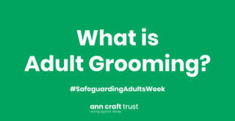
People can experience grooming and exploitation at any age and in a wide range of contexts. Today we want to raise awareness about the different types of grooming for instance, predatory marriage, financial scams, and radicalisation. We want to facilitate conversations about how to recognise the signs of grooming and how to respond to promote safe cultures.
Grooming forms a key part of the exploitation process and is usually associated with sexual exploitation. Grooming is also present in other forms of exploitation including modern slavery, radicalisation, county lines/cuckooing, physical, and financial abuse.
Grooming is the predatory act of manipulating another person into a position that makes them isolated, dependent, likely to trust, and more vulnerable to abusive behaviour. It’s a gradual process and generally starts with a friendship, a romantic relationship, or a relationship of dependence in which the groomer provides something that is valued, such as monetary goods or self-validation and acceptance.
How to Spot the Signs of Adult Grooming, Learn more.
Adult Grooming In Sport – If It Feels Wrong, It Is Wrong. Read more.
An introduction to predatory marriage podcast. Listen here.
Look Closer – How to Spot the Signs of Abuse and Exploitation. Learn more.
My Marriage My Choice is a new website with information and resources for people at risk of, or currently experiencing forced, unlawful or predatory marriage.
Tricky Friends is a new animation, created by Norfolk Safeguarding Adults Board, that helps people with learning disabilities understand true friendships.

Signs of Grooming
Ann Craft Trust – Signs of Grooming

Please see the YouTube link below which shows films commissioned by Surrey CSP’s around Modern Slavery and Cuckooing

The effects of grooming
Like all forms of abuse the survivor will be left with emotional trauma and even physical injuries. One of the main effects of grooming is that the survivor is left carrying the shame of the events. The self-blame of feeling like they let it happen makes the abuse even more difficult to talk about. Grooming makes it increasingly hard to identify when abuse is happening, and more difficult to identify and talk about past events which may re traumatise the survivor.

What To Do If Your Suspect Grooming is happening
Safeguarding is everyone’s responsibility, and you must take action if you have any concerns about someone’s safety or welfare. If you suspect somebody is being harmed, don’t ignore it, report it.
In an emergency – Dial 999 for the police.
If you are concerned about an adult with care and support needs, who is at risk of/ or is being abused or neglected and is unable to protect themselves please refer your concern to the ASC MASH, using the ASC MASH referral form using the level of need toolkit.
For any other advice or support please refer to the appropriate service using the level of need toolkit, here you will also find the contact details and MASH referral form.
ASC Reporting a concern level of need toolkit
SSAB Guide to Reporting Abuse and Safeguarding Enquiries

SCC, ASC - Information and advice
Availability: 9am to 5pm, Monday to Friday
Phone: 0300 200 1005
Email: contactcentre.adults@surreycc.gov.uk
Textphone (via Text Relay): 18001 0300 200 1005
SMS: 07527 182 861 (for the deaf or hard of hearing)
VRS: Sign Language Video Relay Service
Fax: 020 8541 7390
Or send your enquiry using the SCC online enquiry form which is confidential and secure for you to use.

Concerns of abuse or neglect
If you’re at risk of the above, or suspect someone else is, you need to report it.
To do this, contact the Multi Agency Safeguarding Hub (MASH):
Availability: 9am to 5pm, Monday to Friday
Phone: 0300 470 9100
Email: ascmash@surreycc.gov.uk

To report a concern: please use the ASC level of need toolkit to assist you in referring to the correct team.
Please note emails are secured by TLS .
Please remember that all emails containing sensitive information should continue to be protectively marked.

Out of hours: Adult Social Care Emergency Duty Team: 01483 517898

Friday- Creating Safer Organisational Cultures
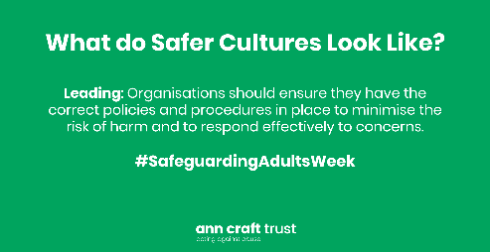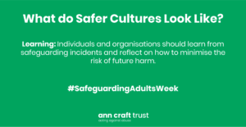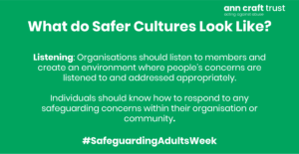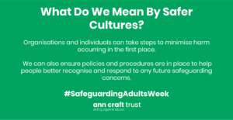
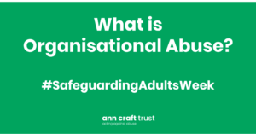
Today we want to hear from you! Tell us what you are doing in your organisation to create safer cultures. Today we will also be focusing on including voices of people less likely to raise concerns and promote learning in safeguarding practice to promote safer cultures.
What is a Safer Culture? Learn more.
Explore our leisure industry checklist that helps organisations to develop a safer culture. Take a look.
Test your safeguarding knowledge by completing our free safeguarding assessment.
Learn about how you can participate in our Safer Culture Safer Sport campaign. Listen now.
Develop your safeguarding policy using our templates. Take a look.
Listen, Learn and Lead. How can you create a safer culture? Read more.
Reporting and recording safeguarding issues is key to creating safer cultures. Learn more.
Download our training resources to support you with starting conversations about safeguarding best practice in your organisation.

Saturday & Sunday- Safeguarding and You
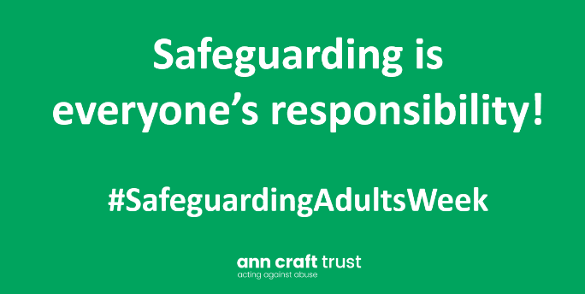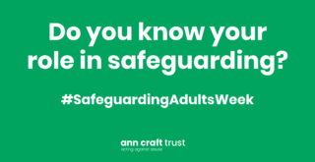
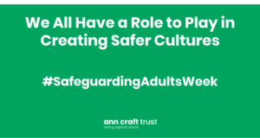
Do you know what your role in safeguarding is? Safeguarding is for everyone. It is not just about knowing your role in an employment setting, but also knowing your role as a person in everyday life, to promote a safer culture in the community. We want to highlight that safeguarding is everyone’s responsibility and everyone needs to play their part to effectively create safer cultures.

