Safeguarding Adults Week 2022

Social Media Campaign

Monday 21 - Sunday 27 November
Please use the following tags: #SafeguardingAdultsWeek #SAW2022

The SSAB has taken information from the Ann Craft website so please look at this also as they are offering some free seminars that may be of interest Safeguarding Adults Week 2022 - Links, Resources and More - Ann Craft Trust.

Feel free to adapt information enclosed for your own agency and don’t forget to follow the Surrey Safeguarding Adults Board on Twitter @SurreySAB and subscribe to our YouTube channel Surrey Safeguarding Adults Board - YouTube

Date | Theme | Tweets/posts | Things you might want to tweet/post about | Resources
Monday 21st November |  |  |  | The SSAB Independent Chair will doing a video introducing the week – will be on the SSAB website  www.surreysab.org.uk  and twitter feed  @SurreySAB
Monday 21 November | Exploitation and county lines | County lines can refer gangs and organised criminal networks involved in exporting illegal drugs into areas across the UK. They are likely to exploit children and adults at risk and will often use coercion, intimidation and violence. #SafeguardingAdultsWeek | Share definitions of what county lines, exploitation and cuckooing is. Use the social media assets to help! | County-Lines-Factsheet.pdf (anncrafttrust.org)  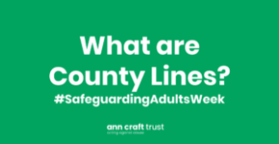  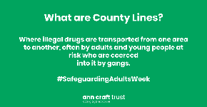  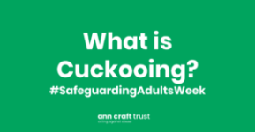  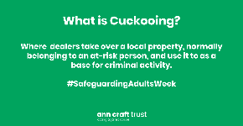  CrimeStoppers is an independent UK charity that allows anyone to share information anonymously.  They’ve been campaigning on county lines since 2018.  Read the National Crime Agency’s detailed primer on County Lines.  Learn about the Home Office’s County Lines Programme.  County Lines and Criminal Exploitation of UK University Students – University of Central Lancashire Report.
 |  | Today is day one of the #SafeguardingAdultsWeek and the focus is on exploitation and county lines.
 |  | Today is day one of #SafeguardingAdultsWeek. For 2022 the focus is on ‘Responding to Contemporary Safeguarding Challenges’.
Tuesday 22 November | Self-neglect | Self-neglect is when  A person neglects to care for their own personal health, hygiene, or surroundings. It  can involve a refusal to seek medical assistance. #SafeguardingAdultsWeek | Share definitions of self-neglect and resources about how to spot the signs and respond if you are concerned about someone.  Promote the route for self-neglect referrals in Surrey as shown in the ASC level of need document | Self-Neglect-Factsheet-v1.pdf (anncrafttrust.org)  Adult-Social-Care-Levels-of-Need-V5-August-2022-.pdf (surreysab.org.uk)  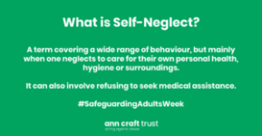  The term “self-neglect” covers a wide range of behaviour neglecting to care for one’s personal hygiene, health or surroundings.  Read blog, ‘What is Self-Neglect?’  A brief introduction to Self-Neglect from The Social Care Institute for Excellence.  Elsie’s Story – a short Self-Neglect case study.
 |  | It’s day two of #SafeguardingAdultsWeek we want to encourage individuals and organisations to learn more about self-neglect. Do you know how to spot the signs and respond?
 |  | It’s day two of #SafeguardingAdultsWeek and the focus is on self-neglect.
Wednesday 23 November | Creating Safer Organisational Cultures | It’s day three of #SafeguardingAdultsWeek and the focus is on Creating Safer Organisational Cultures. @AnnCraftTrust want to encourage organisations to share best practice in relation to how to create safer cultures. | Share resources about how to create safer organisational cultures.  Tell us about what steps you are taking in your organisations e.g. are your staff undertaking safeguarding training regularly or do you have a dedicated contact to respond to safeguarding concerns?  Have you got a safeguarding policy, tell us where this can be found! | Safer-Cultures-Factsheet.pdf (anncrafttrust.org)  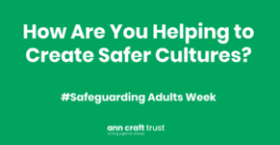  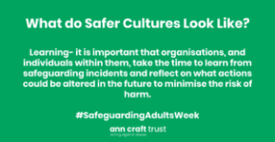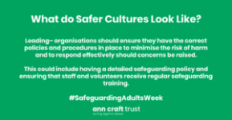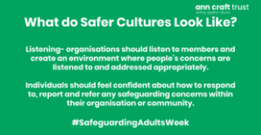  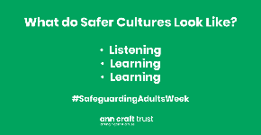  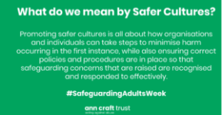  Listen to our podcast with the Rugby Football Union to learn about the role of safe recruitment in creating safer cultures.  Join our  #SaferCultureSaferSport campaign  Learn more about creating safer cultures in the health and social care sector.  Complete our free safeguarding checklist to assess your organisation’s safeguarding practices!  Download our training resources to support you with starting conversations about safeguarding best practice in your organisation.
 |  | Check out @AnnCraftTrust for top tips on creating #SaferCultures in your organisation and access free resources!
 |  | Today we’ll explore how to start difficult conversations about safeguarding adults and consider how organisations and individuals can develop cultural competencies to respectfully respond to the needs of the diverse populations they are supporting.
 |  | Interested to see how much you know about safeguarding? Complete the safeguarding adults checklist to test your knowledge: https://www.anncrafttrust.org/checklist-overview/ #SafeguardingAdultsWeek
Thursday 24 November | Elder Abuse | It’s day four of #SafeguardingAdultsWeek and @AnnCraftTrust are raising awareness of elder abuse. | Share resources to raise awareness about elder-abuse and how to respond. | Elder-Abuse-Factsheet.pdf (anncrafttrust.org)  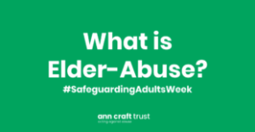  HourGlass, the Safer Aging charity, is committed to stopping elder abuse. Take a look at some of their resources for safeguarding elderly people.  Take a look at AgeUK’s hub of safeguarding resources.  7 Types of Elder Abuse and How to Prevent It. This is a US resource, so it may refer to legislation that doesn’t apply to the UK. But it still features lots of useful information.
 |  | Elder abuse is a single or repeated act, or lack of appropriate action, occurring within any relationship where there is an expectation of trust, which causes harm or distress to an older person. Check out @AnnCraftTrust to learn more.
 |  | People can experience elder abuse in a wide range of contexts. Learn about how to spot the signs this #SafeguardingAdultsWeek
 |  | Elder abuse is a single or repeated act, or lack of appropriate action, occurring within any relationship where there is an expectation of trust, which causes harm or distress to an older person.
 |  | People can experience elder abuse in a wide range of contexts. Learn about how to spot the signs this #SafeguardingAdultsWeek

Friday 25 November | Domestic Abuse in Tech-Society | Today marks the start of 16 Days of Action for VAWG. To support this campaign, we are raising awareness of the role technology has in exacerbating instances of #domesticabuse #SAW2022 | Share resources about how to spot the signs a person may be at risk through their technology and how to respond.  Do you know how to turn off location sharing or how to protect your passwords? Sharing information such as this can be helpful in learning how to stay safe online and minimise the extent to which people are at risk through their technology. | Tech-Society-Fact-Sheet.pdf (anncrafttrust.org)  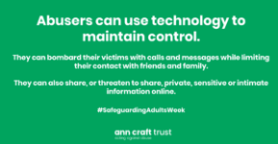  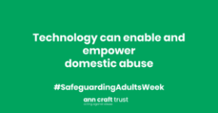  This day marks the start of 16 Days of Action for Violence Against Women and Girls. So to support this campaign, we are raising awareness of the role technology has in exacerbating instances of domestic abuse.  Refuge has published resources to support people at risk of tech-abuse.  UCL have illustrated how smart devices present new risks for victims of domestic violence & abuse.  SafeLives have produced a guide for practitioners to support them to have conversations with adults at risk about using technology safely.  Explore our introduction to digital safeguarding guide which explains what digital safeguarding is and provides tips and advice for staying safe online.  AVA, CAST and Comic Relief collaborated on a comprehensive Digital Safeguarding Resources Pack.
 |  | Technology can help to keep people safe. But abusers can also use technology to cause harm. #SafeguardingAdultsWeek
 |  | Do you know about the role technology can have in relation to domestic abuse? #SafegaurdingAdultsWeek
Saturday 26 & Sunday 27 November | Safeguarding in Everyday Life. | It’s day six of #SafeguardingAdultsWeek and the focus is on safeguarding in everyday life! Learn more about your role in safeguarding. | Make sure you know your role in safeguarding  Share resources about how employers, employees, volunteers and members of the community can contribute to good safeguarding practice and safer cultures.  Have you developed initiatives to support people in the local community? This could be about tackling loneliness or how to respond if you are concerned about someone in your neighbourhood. We would love to hear from you!  Book onto one of our e-learning courses to develop your knowledge. | Safeguarding-in-Everyday-Life-v1.pdf (anncrafttrust.org)  Read our short guide – What Is My Role in Safeguarding – to find out how you can make a difference.  Watch our short video guide to what you should do if you have safeguarding concerns.  Read our guide – What Should I Say…? Responding to Personal Accounts About a Traumatic Experience.  Explore our guide for advice about starting difficult conversations.
 |  | Do you know what your role in safeguarding is? We want to highlight that safeguarding is everyone’s responsibility.
 |  | It’s the final day of #SAW2022! Tell us about how you are developed #safeguarding initiatives in your community!
 |  | Today we’ll be sharing resources about the actions you can take if you witness incidents of discrimination or bullying in everyday life. #SAW2022
General Tweets |  | We are supporting #SafeguardingAdultsWeek 2022! |  | 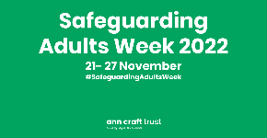  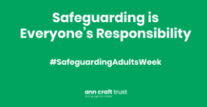  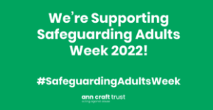  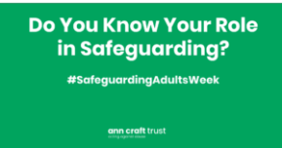
 |  | This #SafeguardingAdultsWeek marks the 30th anniversary of the @AnnCraftTrust! Check out their range of free resources to improve your #safeguarding knowledge!
This week we are supporting #SafeguardingAdultsWeeks

Do you know that the Surrey Safeguarding Adults Board has lots of information on their website?
www.surreysab.org.uk

Follow Surrey Safeguarding Adults Board
@SurreySAB

*information taken from Safeguarding Adults Week 2022 - Links, Resources and More - Ann Craft Trust

Resources; Surrey Safeguarding Adults Board (surreysab.org.uk)

NB. To save all pictures right click, save as.
