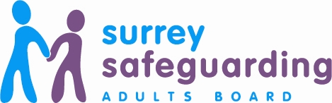What can you do to protect yourself and/or others from abuse and neglect?

With each kind of abuse, neglect, undue pressure or assault, there is often someone who knows it is happening or suspects that something is wrong.

Please use the contact numbers on this leaflet to report abuse or seek advice if you feel you are being abused, or think somebody is at risk of abuse or neglect. You can ask someone you trust to help you.

If possible, let the person who is being abused know help is available and include them in the decision to seek help. You could share this leaflet with them, unless doing so may place them at further risk.

What happens after abuse is reported?

If you report abuse:

- Every report of abuse is taken seriously.

- You will be listened to and asked to provide information about the situation.

- You will be encouraged to give your name to enable your concerns to be followed up.

- Professionals will make enquires about the concerns. They will contact the adult at risk to involve them in the safeguarding process wherever possible, unless to do so may place them at further risk initially.
If you are concerned about an adult with care and support needs:

Surrey Multi Agency Safeguarding Hub (MASH):

0300 470 9100

Out of hours: Adult Social Care Emergency Duty Team
01483 517898

Textphone (via Text Relay):
18001 0300 200 1005

SMS:
07527 182 861 (for the deaf or hard of hearing)

If you suspect somebody is being abused or neglected, don’t ignore it, REPORT IT!
In an emergency – Dial 999 for the police.

For further information go to:
Surreysab.org.uk

Or email us at:
Surreysafeguarding.adultsboard@surreycc.gov.uk

Concerned about an adult?

We are committed to work together to enable people in Surrey to live a life from fear, abuse and neglect.

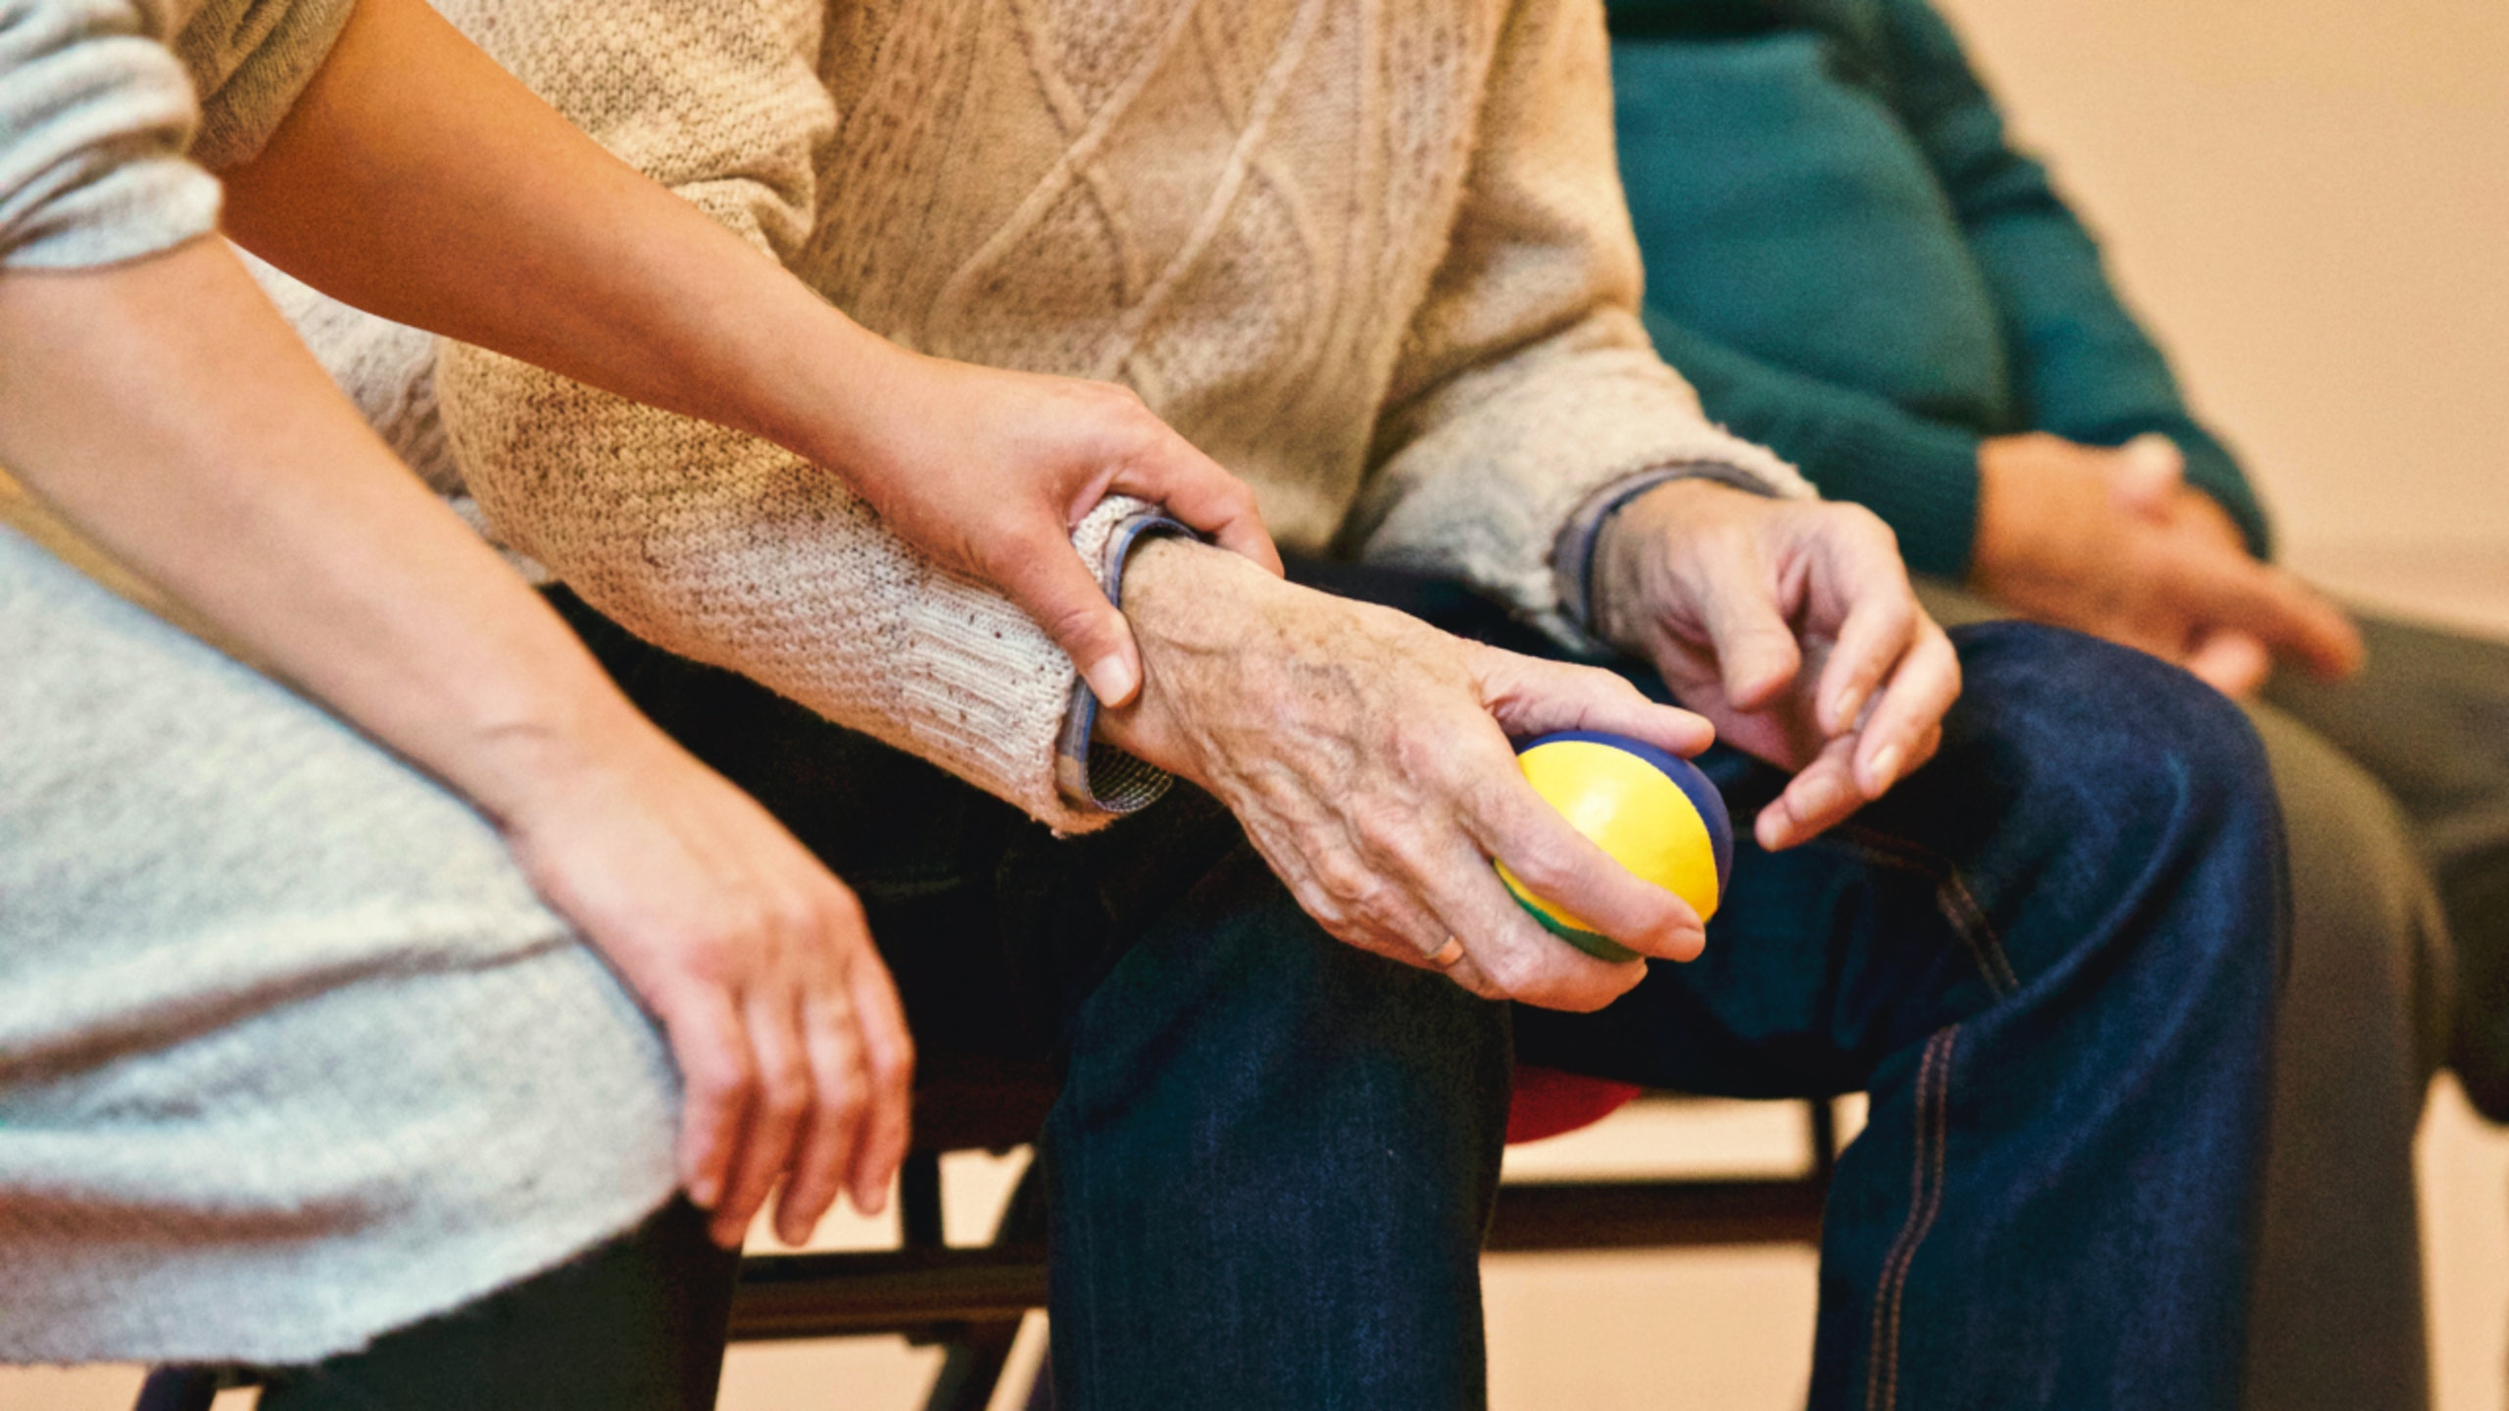

Concerned about an adult?

Safeguarding adults duties apply to an adult who has care and support needs, is experiencing or at risk of abuse and neglect, and is unable to protect themselves a result of their care and support needs.
What is abuse and neglect?

People with care and support needs, such as older people or people with disabilities, are more likely to be abused or neglected. They may be an easy target and may be less likely to identify abuse themselves or to report it. People with communication difficulties can be particularly at risk because they may not be able to alert others.

Types of Abuse

The different types of abuse are described below.

Physical abuse is when someone is physically injured by another person, for example through assault, such as slapping, pushing, kicking or rough handling. It can also include the misuse of medication, or inappropriate sanctions or restraint.

Domestic abuse is when abuse occurs between partners, former partners or by a family member. It can include psychological, physical, sexual, financial or emotional abuse as well as ‘honour’ based violence, forced marriage and female genital mutilation.

Sexual abuse relates to any sexual activity which the adult has not consented to, was not able to consent to or was pressured into consenting to. This can include rape, sexual assault or harassment, sexual photography, subjection to pornography or inappropriate touching.

Psychological abuse includes emotional abuse, verbal assault, intimidation, bullying, cyber bullying, abandonment, humiliation or blaming. Any unjustified withdrawal of services or support networks is also a form of psychological abuse, as is not letting the person have choices or ignoring their wishes.

Modern slavery is when individuals are coerced, deceived or forced into a life of abuse, servitude and inhumane treatment. This can be through human trafficking, forced labour or domestic servitude.

Financial or material abuse relates to theft, fraud, internet fraud/scams, exploitation or pressure in connection with financial affairs or arrangements. It can also include the misuse or misappropriation of property, possessions or benefits.

Discriminatory abuse is when a person suffers ill-treatment or harassment because of their race, gender, cultural background, religion, physical and/or sensory impairment, sexual orientation or age. This can be referred to as hate crime.

Organisational abuse is where an adult is placed at risk through poor professional practice and/or organisational failings. It can be a one-off incident or ongoing ill-treatment or neglect. This abuse can happen when care and support is provided at home or within an institution or care setting, such as a hospital or residential home.

Neglect is when someone deliberately or unintentionally causes a person to suffer by failing to provide the required medical or physical care. This may include failing to provide access to appropriate health, social care or education. This can result in their essential day to day needs, such as: medication, food, drink and heating, being denied.

Self-neglect is when a person’s behaviour, such as neglecting to care for personal hygiene, health or surroundings, has a detrimental effect on their health and wellbeing. It can include behaviour such as hoarding.

