
Safeguarding Adults Week 2025
Social Media Campaign
Monday 17 - Friday 21 November
Please use the following tags: #SafeguardingAdultsWeek #SurreySAB

Date | Theme | Tweets | Resources/ Training
Week Before | General Tweets | #SafeguardingAdultsWeek takes place next week 17-21 November. This year’s theme is #Prevention, act before abuse.  #It’s time to change the conversation.  Safeguarding Adults Week 2025 - Tell Your Story on Vimeo | https://www.anncrafttrust.org/wp-content/uploads/2025/06/Safeguarding-Adults-Week-Poster-1.png  https://www.anncrafttrust.org/wp-content/uploads/2025/06/Safeguarding-Adults-Week-2025-Poster-2.png  https://www.anncrafttrust.org/wp-content/uploads/2025/06/Safeguarding-Adults-Week-Poster-3.png  https://www.anncrafttrust.org/wp-content/uploads/2025/06/Safeguarding-Adults-Week-Poster-4.png
Week Before | General Tweets | We are supporting @AnnCraftTrust #SafeguardingAdultsWeek Monday 17-21 November 2025!  Safeguarding Adults Week 2025 - Tell Your Story on Vimeo
Monday 17 November | Change the conversation | Today marks the start of #SafeguardingAdultsWeek This year’s themes are all about #Prevention, act before abuse. | Ann Craft Trust are holding an online seminar on  Sexuality & relationships in the lives of adults with learning disabilities  1:30 pm – 2:30 pm Book your place
Monday 17 November | Change the conversation | Today is day one of the @AnnCraftTrust #SafeguardingAdultsWeek and the focus is on #Prevention, act before abuse. | 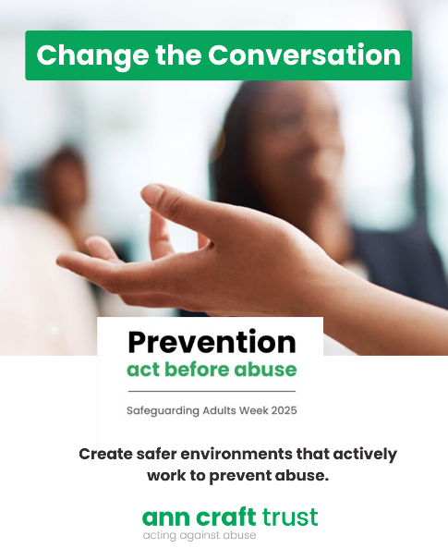
Tuesday 18 November | Prevention in Practice | Today is day two of #SafeguardingAdultsWeek todays focus, is on Prevention in Practice  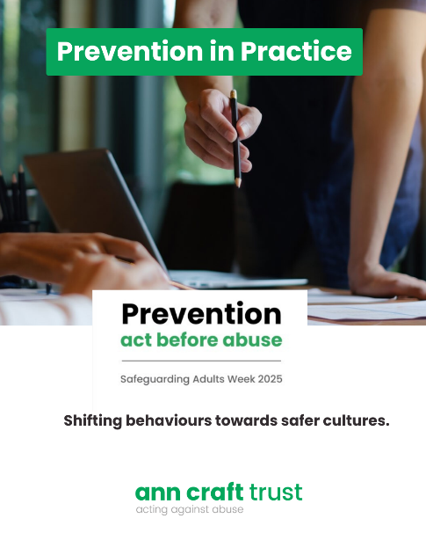 | Surrey and Borders Partnership Trust (SaBP) are holding a Lunch and Learn on Preventing Domestic Abuse at 12pm on Microsoft Teams. Join the meeting now
Tuesday 18 November | Prevention in Practice |  | Ann Craft Trust are hold an online seminar Preventing Forced Marriage  3:30pm – 4:30pm.
Wednesday 19 November | Creating Empowering Environments | It’s day three of #SafeguardingAdultsWeek and the focus is on Creating Empowering Environments.  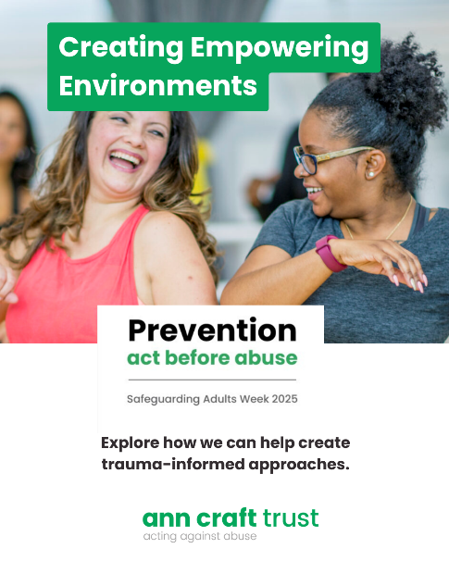 | Hear from Healthwatch Surrey and Surrey Heartlands ICB in a joint webinar on In Safe hands? Domestic abuse survivors' experience of general practice. At 12:30.  Webinar Series - Surrey Safeguarding Adults Board
Wednesday 19 November | Creating Empowering Environments |  | Trauma informed practice - NHS Safeguarding
Thursday 20 November | Trust Your Instincts | It’s day four of #SafeguardingAdultsWeek and today looks at Trust your Instincts.  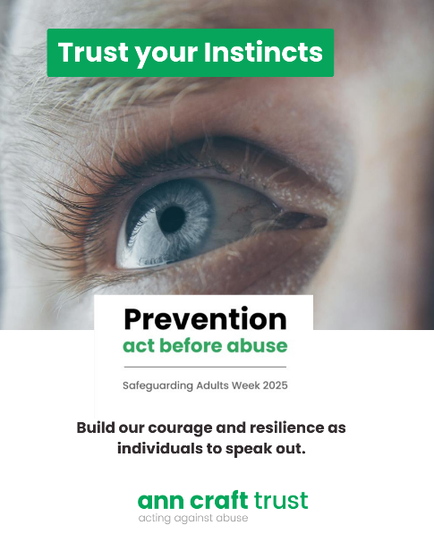 | Ann Craft Trust  Trust Your Instincts: Physical Abuse and Safeguarding Adults  11:30am – 12:30pm  Book your place
Thursday 20 November | Trust Your Instincts |  | Professional Curiosity & Safeguarding Adults - An Essential Introduction - Ann Craft Trust
Friday 21 November | Celebrate the Safer Cultures | It’s the final day of #SafeguardingAdultsWeek  Today’s theme is Celebrate Safer Cultures.  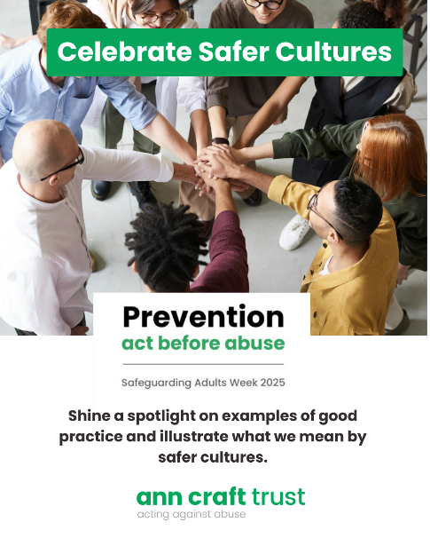

Additional resources:
Leaflets & Resources - Surrey Safeguarding Adults Board

